

AGENDA PAPERS MARKED ‘TO FOLLOW’

PLANNING DEVELOPMENT CONTROL COMMITTEE

Date: Thursday, 9th September 2010

Time: 6.30 p.m.

Place: Committee Suite, Trafford Town Hall

 | A G E N D A PART I | Enclosure  No. | Proper Officer  under L.G.A., 1972, S.100D (background papers):
5. | APPLICATION FOR PLANNING PERMISSION 75607/VAR/2010 – MR. WILKINSON, WILLIAMS TARR DEVELOPMENTS – 231 ASHLEY ROAD, HALE  To consider the attached report of the Chief Planning Officer. | 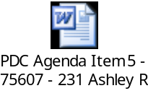
JANET CALLENDER
Chief Executive

Contact Officer: Miss Michelle Cody
Extn.: 2775

